Car Booking Reservation System Using Zoho One (SaaS)

Aim
To create a simple Car Booking Reservation System using Zoho One as a cloud-based SaaS application.
Steps / Procedure
- Log in to the Zoho One cloud platform.
- Open Zoho Creator from Zoho One.
- Create a new application for car booking.
- Create a form named Car Booking Reservation.
- Add the required fields:
  - From
  - To
  - Rental
  - Outstation
  - Package Type
  - Hours/Days
- Select the suitable field type for each field.
- Arrange the fields properly in the form.
- Save and publish the form.
- Enter sample car booking details.
- Submit the form.
- Check whether the booking details are stored in the cloud.
- Test the form with different booking details.

Implementation

Input:
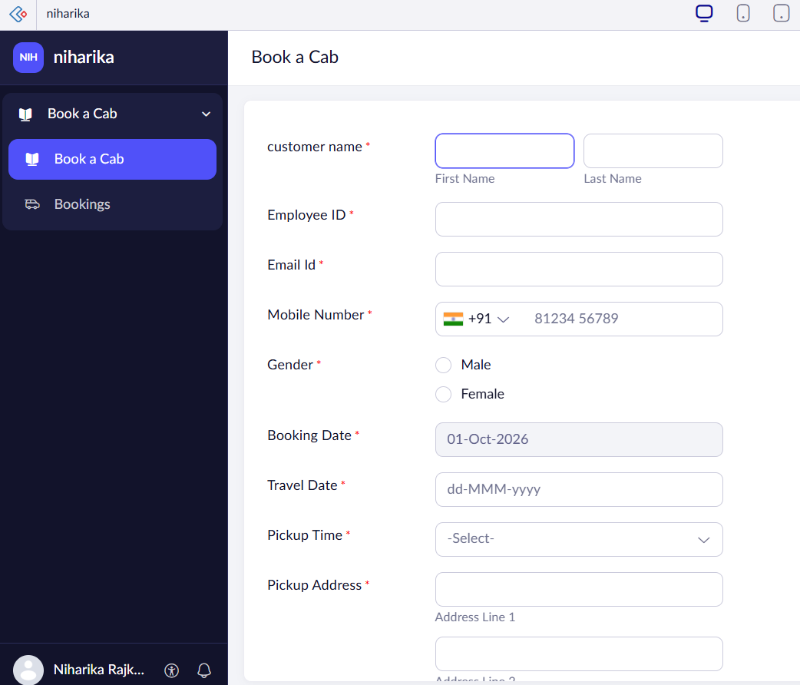
Output:
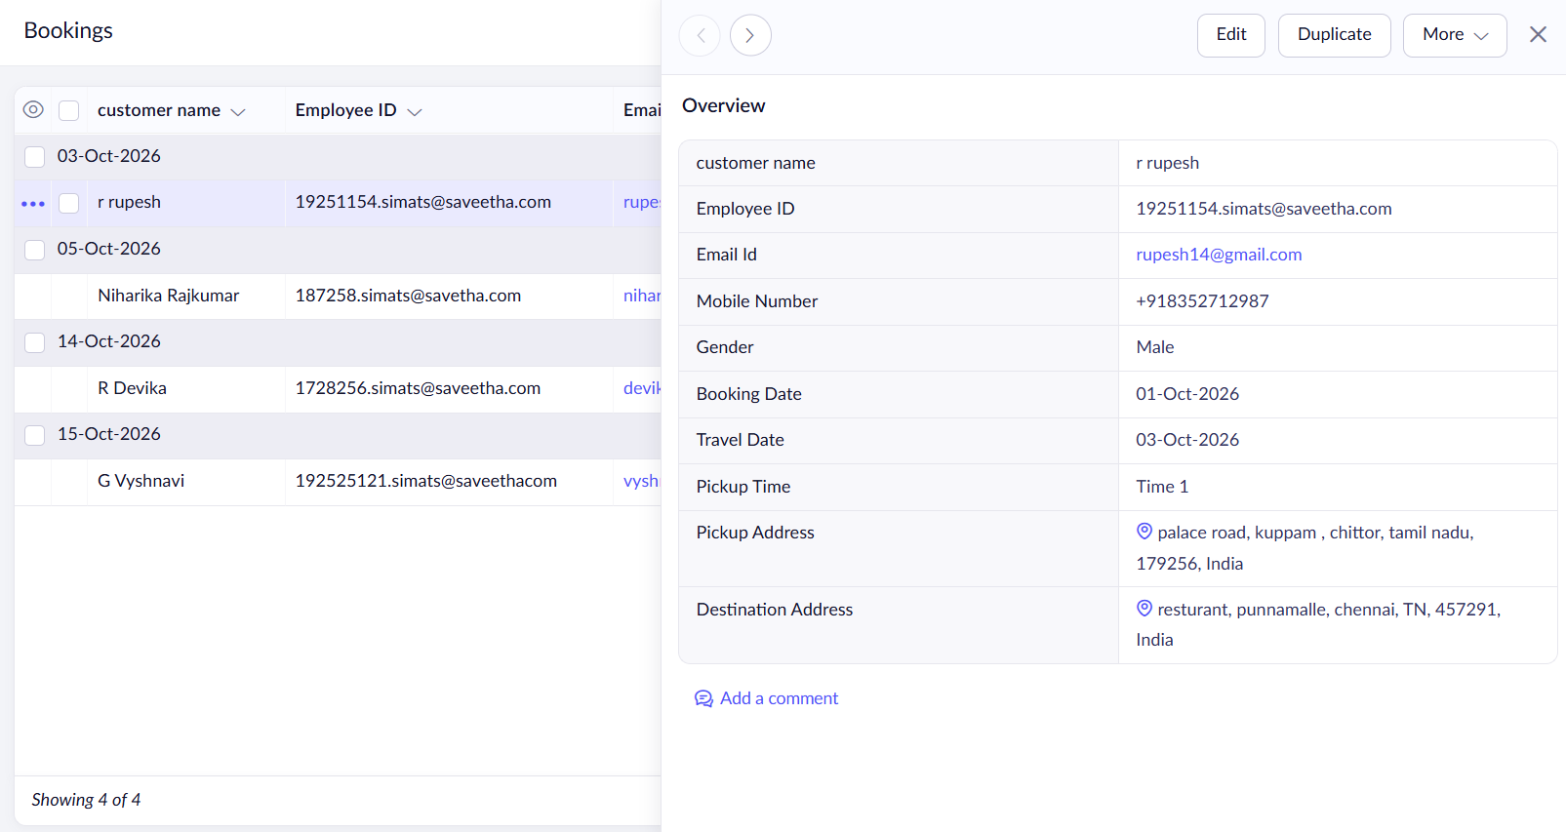

Result
Thus, the Car Booking Reservation System was successfully created using Zoho One and works as a SaaS application.

